***Experiment 1***

**Aim:** Installation of Hadoop on local machine.

***DataNode:***

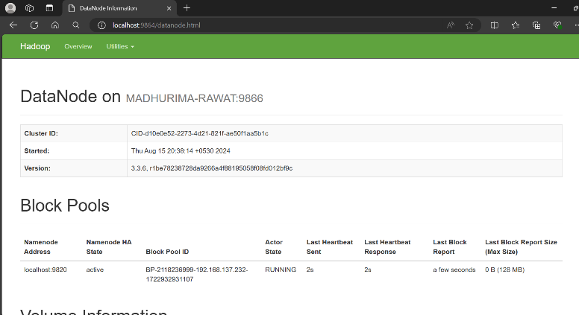

***Fig 1: DataNode in Localhost***

***NameNode:***

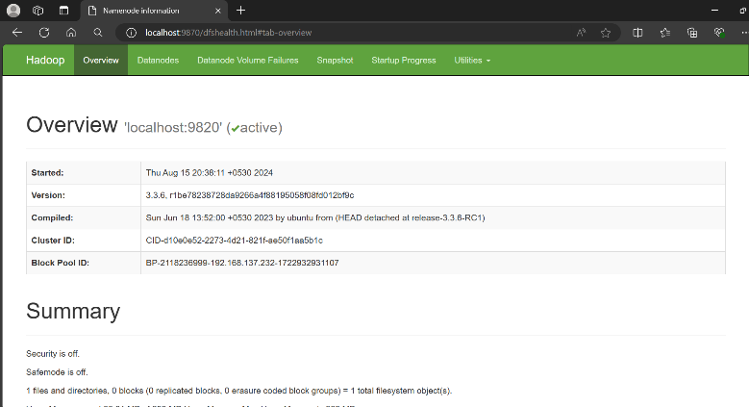

***Fig 2: NameNode in Localhost***

***Hadoop Cluster:***

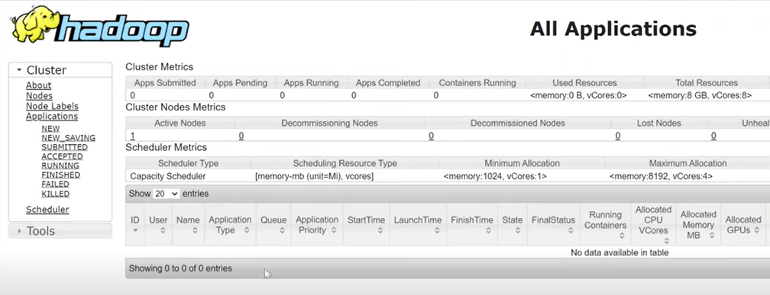

***Fig 3: Hadoop Cluster in Localhost***